Chapter-17
Ministry of Disaster Management and Relief
1.0 Introduction
1.1 Global warming and climate change impacts increased disasters throughout the world and Bangladesh is known as one of the most disaster prone countries in the world. The country faces wide range of natural disaster due to its geographical position, soil structure and geological condition. Around 135 million People of this country have been affected by natural disaster in last 2 decades. According to the World Risk Index, 2016, Bangladesh is the 5th most disaster risk prone countries in the world out of 171 countries that are reviewed on the basis of overall risk measured in terms of Exposure, Susceptibility, Coping, and Adaptation of infrastructure and crops and of human and other animals. Though the people have the instant capacity to return back from disaster but the position of Bangladesh is at risk due to lack of infrastructure and capacity of long term adaptation. Increasing number of natural disasters due to environmental degradation and global climate change are also affecting the country like many other countries. Poor people, mainly women, elderly, children, and disabled become the main victim of disaster. The extent of sufferings can be kept minimum by ensuring optimum level of disaster preparedness. For this reason, disaster preparedness has to be ensured. The number of casualty and wounded people would be less if the rescue operation can be carried out timely and carefully. The Ministry of Disaster Management and Relief provides shelter and supplies food, clothes, water etc. to the affected people during the time of disaster. The ministry distributes money and supplies food to the poor people round the year and imparts vocational training in order to make them permanently self-reliant. Moreover, the ministry plays an important role to ensure uninterrupted communication and better living standard by constructing small bridges and culverts, Herring Bone Bond (HBB) roads and by mud-filling of the playgrounds of schools, colleges and other institutions and constructing toilets for those institutions. The ministry plays an important role to reduce disaster risk, undertakes post-disaster rehabilitation programmes, implements various social safety net programmes and builds physical infrastructures e.g. flood shelters and multi-purpose cyclone centers in coastal belts, small bridges and culverts and disaster tolerant houses in the rural areas and also procures equipment to rescue earthquake and other disaster victims.
1.2 The preparedness of the government institutions and due to consciousness of the people the risk of flood and cyclone has reduced considerably in Bangladesh. The multi-dimensional steps to reduce the risk of urban infrastructure and climate change have been undertaken like urban resilience programmes and other programmes to reduce the risk of climate change. In 2015, the Honorable Prime Minister of Bangladesh Sheikh Hasina was honored with the highest environmental accolade of the United Nations, ‘Champion of the Earth’ in policy leadership category in recognition of Bangladesh’s far-reaching imitative to address environment and climate change.
The long term vision of the Government in disaster management is to reduce the vulnerability of the people, especially the poor from natural, environmental and manmade disasters, to a tolerable and humanly reasonable level and also seeks to establish a capable emergency disaster response system to combat large scale disasters. To reach these goals, the Ministry of Disaster Management and Relief is working to upgrade the traditional post disaster response and relief work to a system of overall risk reduction management. At the same time, one of the major task of this ministry is to alleviate poverty and to generate employment opportunity for the ultra poor during seasonal unemployment. For these reasons Bangladesh has been acclaimed as a role model in the world in combating disaster.
1.3 Beneficiaries are selected on the basis of gender in various projects of this ministry and gender equity is promoted through some programmes that give priority to women. Women and children are considered as the most vulnerable to disasters and that is the reason why they are given priority in disaster management and the distribution of relief goods. In some cases, women are not only the beneficiaries but also involved with implementing activities through government initiatives. Besides this, some social safety net programmes like Employment Generation for the Poorest (EGPP), Test Relief (TR), Food for Work (FFW), and Vulnerable Group Feeding (VGF) are being implemented with a special focus on women.
2.0 Major Functions of the Ministry
- Formulation and implementation of laws, policies and action plans for disaster risk reduction, emergency response and disaster management;
- Preparation of policies and plans for providing urgent humanitarian assistance and rehabilitation programmes and preparation and preservation of all social safety net programmes implemented by the ministry;
- Preparation of disaster risk reduction plans, taking up activities for training and research, and coordination, monitoring and evaluation among local, regional and international development partners;
- Providing humanitarian assistance to ensure food security through the preparation and implementation of Rural Infrastructure Development, Rural Infrastructure Maintenance, VGF, GR, and other programmes;
- Ensuring employment for the ultra-poor during the lean period of the year to reduce risk;
- Coordination of the use and distribution of emergency food aid and other humanitarian assistance received from abroad;
- Implementation of programmes related to refugee affairs and co-ordination with the relevant national and international agencies.
- Reduce disaster risk trough construction of small bridges/culverts, multi-purpose cyclone/flood shelters, Mujib Killas, Relief go-down-cum-information centers, herring Bone Bond roads etc.
3.0 Strategic objectives of the Ministry and their Relevance with Women’s Advancement and Rights
3.1 The strategic objectives to reduce the risks of disaster especially for the poor and the vulnerable to a manageable level by way of strengthening the overall capacity of disaster management and their relevance to woman’s advancements and rights are as follows:
- Institutionalizing disaster management system, creation of professionalism and increasing the capability: In disaster prone areas, the capability of women to face natural disasters has been enhanced due to their involvement in disaster awareness activities and livelihood training. As a result, poverty and disaster risks are reduced.
- Construction of infrastructure to reduce disaster risks: An effective transport system plays a supportive role in rescuing people especially women and children during disasters. The lives of women and children are also saved at shelters provided during floods and cyclones. The overall benefits of communication and transport accelerate women’s advancement.
- Reducing the sufferings and disaster risks for vulnerable people: At least 30 percent of the beneficiaries are women under targeted and women friendly programmes. As the poor and destitute women are getting preferential employment, their income is increasing and their access to food is improving. Women, children and handicapped people are taken to the safe shelters on a priority basis at the beginning of any serious disaster and they are given food and medicines. As a result, their social security and capacity to face disasters are being strengthened.
4.0 Roles and Responsibilities of the Ministry for Women’s Advancement and Rights
4.1 One of the major functions of the Ministry of Disaster Management and Relief is disaster risk reduction, response to the emergency, the formulation of laws relating to disaster management, the implementation of policies and action plans. The Ministry has enacted Disaster Management Act, 2012 and in continuation of that formulated the National Plan for Disaster Management 2016-2020 with an objective for overall development in disaster management where women related issues have been identified.
4.2 The Department of Disaster Management has initiated a facilitator’s guidebook titled ‘Practicing Gender & Social Inclusion in Disaster Risk Reduction’ which intends to provide thorough outlines for analyzing and managing the risk situations of the most vulnerable groups in Bangladesh by capturing their own voices. The guideline enables the disaster professionals to increase the level of awareness and the response capacities of local communities to the potential and frequent natural disasters, as well as to reduce the effects of these frequent disasters on the most vulnerable groups. This guidebook provides guidance for disaster professionals in Bangladesh in carrying out risk management and emergency response programmes by unfolding the ways to target the most vulnerable categories in the process.
4.3 This ministry has extended the following priority activities to create opportunities for women:
- Social safety net program: The safety net programs like Employment Generation Programme for the Poorest (EGPP), Food for Work (Kabikha), Rural Infrastructure Development Programme (Kabita), Rural Maintenance Progrrame(TR) and VGF Programmes play important roles to increase availability of food to the extreme poor during slump and disaster periods. Most of the beneficiaries of these programmes are poor women. Under EGPP programme 80 days employment in 2 phases being undertaken for rural road maintenance. In this program, at least 30 percent of total beneficiaries are women.
- Construction and maintenance of Flood and Cyclone Centers: During disasters citizens especially women and children take shelter at Flood and Cyclone Centers which are children and women friendly.
- Disaster risk reduction program in disaster prone areas: Women are being involved in awareness building activities concerning disasters which improve their skills. To reduce the loss both to lives and properties, community empowerment, capacity building, response management activities are also being undertaken. Women and children are taken to the safe shelters when there are disaster warnings. Medicines are being distributed to them. As a result, disaster risk of women and children is being reduced which enhances their overall social and economic status. Prediction for relocation is to provide specially the relocation of women and children to the safe places during the probable time of disaster.
- Construction of physical infrastructure: Better communication and transportation systems especially in rural and coastal regions are conducive for women’s development as they help to reduce the impact of disasters and promote economic development. Uninterrupted communications systems are essential to rescue people specially women, children and elderly persons during disasters. Women are benefitted directly and indirectly through the construction of Flood and Cyclone Shelters, disaster tolerant houses, village connecting HBB roads, small culverts/bridges and other physical infrastructure in disaster prone areas.
- Procurement and maintenance of searching and rescuing vehicles and equipment: This Ministry procures different search and rescue vehicles/equipments to combat disasters which play important role to save lives and properties during disasters. These equipments help save lives of women and children.
- Providing food safety support to the lactating mother/children in order to reduce malnutrition through Nobojatra project: Food security support is being provided to the lactating mothers/children to reduce malnutrition through Nobojatra project implemented by the Ministry. In the last three years, the amount of budget allocation was Tk. 155 crore, 1115 crore and 110 crore respectively.
5.0 Priority Spending Areas for Women’s Advancement
Serial No. | Priority Spending Area/Programs | Impact on Women's Advancement (Direct and Indirect)
1 | 2 | 3
1. | Expansion of Social Safety Net Psrogrammes | - The Employment Generation Programme for the Poorest (EGPP)  This is a targeted and women focused programme of this Ministry. The total allocation in this program in FY 2018-19 was 1,650 crore taka and for the same allocation has been proposed in FY 2019-20. A forty (40) days employment generation programme is being undertaken for rural infrastructure development/repair/maintenance through this programme. At least 33 percent beneficiaries of this programme are destitute and poor women who are being empowered through this program as their income is increasing. In the post disaster period, women are given priorities as per policy while selecting the beneficiaries. So, they get easy access to food grain, cash money, biscuits etc.  - Food For Work Programme ( KABIKHA/KABITA)  Under the Rural Infrastructure Development (KABIKHA/ KABITA) Programme a total of Tk. 1446.39 crore was allocated in FY 2018-19 of which 30 perecent are women beneficiaries. In the FY 2019-20 for Tk. 1582 crore allocation has been proposed.  ∗Rural Infrastructire Maintenance ( TR)  Under this Programme a total cash of Tk. 1390 have been allocated of which 30 percent are women beneficiaries. In the FY 2019-20 for Tk. 1530 crore allocation has been proposed.  - VGF  One of the main social safety net programme is VGF under which Tk. 1730.81 was allocated in FY 2018-19 of which approximately 70 percent were women beneficiaries.  - Emergency Humanitarian Aid  Under this programme in the FY 2018-19 Tk. 48.14 crore and 1,59,983 bundle corrugated iron sheets were distributed among 1,59,983 families for building houses and also 67,13,641 blankets among 40,09,392 destitute families.
2. | Construction of small bridges, culverts and Flood and Cyclone Shelters | - Improved road and transport network helps all affected people especially women and children during disasters. Women and children are benefitted directly and indirectly though flood and cyclone shelters. The overall benefits of transportation facilities accelerate the development of women. Moreover, many women are employed in these construction works every year. For example, around 8.50 lac women is expected to be employed in this year in the construction of small bridges and culvert project.  - 3.72 lac women have been employed in the 117 cyclone shelters and 255 flood shelters construction projects. In the coming five years, more women will be employed in the various construction projects of the ministry, which will play a special role to empower them including poverty reduction.  - The planning Commission conducted a study in 1993 and recommended to construct 6,000 cyclone shelters in the coastal region under which 3,868 multi-purpose cyclone shelters have been built by Government and private agencies. The Ministry has built 117 multi-purpose cyclone shelters in 60 Upazillas of 13 districts during 2011 to 2015 which have benefitted a large number of women and children. Presently, construction of 220 cyclone shelters are undergoing in 86 upazillas of 16 districts of the coastal belt which will benefit a large number of women and children.  - Different Government and private agencies so far constructed 306 flood shelters. This Ministry constructed 99 shelters from 2008 to 2010 and 156 shelters from 2013 to 2016 in total 255 shelters. Presently, construction of 423 flood shelters are undergoing in 247 upazillas of 42 districts which will create employment opportunity for a large number of women.  - To reduce water logging in the rural roads and to improve the rural road network the ministry has constructed 6517 bridge/culverts from 2008 to 2016 ( except Hill Tracts) small and 703 bridge/culverts from 2010 to 2016 in Chattogram Hill Tracts which are of 12 meter length. Implementation of construction of 13000 bridge/culvert of 15 meter length within the period of 2015 to 2019 is going on. From FY 2019-20 construction of another 13000 bridge/culverts will be implemented and about 9 lakh women are expected to be employed.
3. | Procurement and maintenance of search and rescue vehicles and equipment | - Procurement of search and rescue vehicles and equipment play important roles in saving lives and properties during disasters and benefit people, especially women and children.  - Under the project titled ‘Procurement of Equipment for Search and Rescue Operation on Earthquake and Other Disasters (Phase II)’, various equipments worth taka 158 crore have been procured. In the next FY 3rd phase of the project will be commenced with a total cost of Tk. 1000 crore through which women and children will be benefitted.
4. | Risk reduction training, research and awareness programmes | - Since women are considered to be the most vulnerable in every disaster, they will benefit from the risk reduction programmes and training. Provisions of safe drinking water have been made for the women and children under CDMP (Phase-2) project. Women are trained in non-farm livelihood in the disaster affected areas. Under the project, women were imparted trainings on different issues of disaster management. Out of them 10,000 have been trained as CPP volunteers and 8,000 have been trained as Fire Service and Civil Defense volunteers. At district, upazila and union level, 9,540 female members of the disaster management committee and 8,200 school girls and female teachers were trained. Besides, 25,000 women were trained as community members.  - Three hundred and fifty officials from Titas Gas, Armed Forces Division and Fire Service and Civil Defense have been trained on GIS system so that they can respond in emergency situation during disasters more efficiently. 20 percent of the trainees were women.  - In the FY 2018-19 under Harmonized Training Module 14,093 district, upazila and union disaster management committee members from 4 districts have been trained of which many are women.  - Under the ECRRP-D1 project, 1,900 officials from 38 districts have been trained in disaster management and a considerable number of them are women.  - In the coastal region, a project from 2015 to 2020 has been undertaken for voluntary training and to increase the capacity for poor women in urban areas. The development impact of women of this project is about 50 percent.
5. | Mujib Killa Construction, Maintenance & Development | - Mujib Killa construction project is undergoing in cyclone and flood prone areas of the country which will help save cattle lives during the time of disasters and women will be economically from this
6. | District and Upazilla Relief go-down-cum-information center | - Construction of District go-down-cum-information center in all districts is undergoing and another project for Upazilla go-down-cum-information center in all upazillas will start from the FY 2019-20 which will facilitate quick distribution of relief among the women.

6.0 Women’s Share in Ministry’s Total Expenditure
(Taka in Crore)
Description | Budget 2021-22 |  |  | Revised 2020-21 |  |  | Budget 2020-21 |  |  | Actual 2019-20
 | Budget | Women Share |  | Revised | Women Share |  | Budget | Women Share |  | Actual | Women Share
 |  | Women | percent |  | Women | percent |  | Women | percent |  | Women | percent
Total Budget
Ministry Budget
Development
Operating
Source: RCGP database
7.0 Key Performance Indicator (K.P.I) of the Ministry in relation to Woman’s Advancement and Rights in the last three years
Indicators | Unit of  Measurement | Actual Achievement
 |  | 2017-18 | 2018-19 | 2019-20
1 | 2 | 4 | 5 | 5
Woman Beneficiaries of social safety net programme (Employment generation programme for the poorest) | Number  (Lakh person month) | 6.96 | 6.98
Women Volunteer for Cyclone Preparedness | Number in thousand | 9.20 | 950
8.0 Success in Promoting Women’s Advancement
- Under the Comprehensive Disaster Management Programme (C.D.M.P.) phase-ii project, 203 households have been rehabilitated by constructing disaster resilient houses in two disaster resilient villages in Sukrail union under Dacope upazilla in Khulna District. As a result of this, the women of these families, who had been staying on embankments after Cyclone Aila have been given the opportunity to live a decent and secure life. Moreover 260 households in the urban areas have also been rehabilitated; all of these efforts have enhanced their development and rights;
- Sanitary latrines have been installed under CDMP and 203 k.m. of water pipelines have been installed with CDMP and GIZ support in the coastal belt of the country. These have helped the women in the areas by reducing their workload and can now spend more time engaging in productive activities;
- So far, 26,000 urban volunteers and 55,260 volunteers under Cyclone Preparedness Program have been trained and employed to the work. One fifth among them are woman who positively indicates their enthusiasm for social service, thus improving their social status.

Success of Employment Generation of the Poorest (EGPP):
- In the last 10 years, average beneficiaries of EGPP was almost 9 lac, of which one third are women, but in reality the situation is totally different. Wages of women are equal to men and hence more than 50 percent beneficiaries of this programme are women. Following important features have been identified in analyzing impact of EGPP in the research work titled “ Implication of Employment Generation Programme for the Poorest (EGPP) to Reduce Disaster & Gender Vulnerability” conducted by Bangladesh Institute of Development Studies ( BIDS):
- EGPP beneficiary women work at least 45 days more in a year and earn at least Tk. 5692 more than others and hence their food insecurity is comparatively less;
- The mobility to office, NGO, work place, parents home etc. of EGPP beneficiaries are 10-15 percent higher than non-beneficiaries
- Women beneficiaries are more aware than non-beneficiaries regarding issues like knowledge about legal minimum age of marriage, polygamy, law regarding violence against women, birth registration, right to paternal property, legal provisions for women, and healthcare provisions.
- Female beneficiaries claimed to have gained social recognition and status.
- Maya Rani, a female beneficiary in Gangachara of Rangpur district says,”We are given more importance at the household and community level since we are earning money. Domestic violence has reduced”
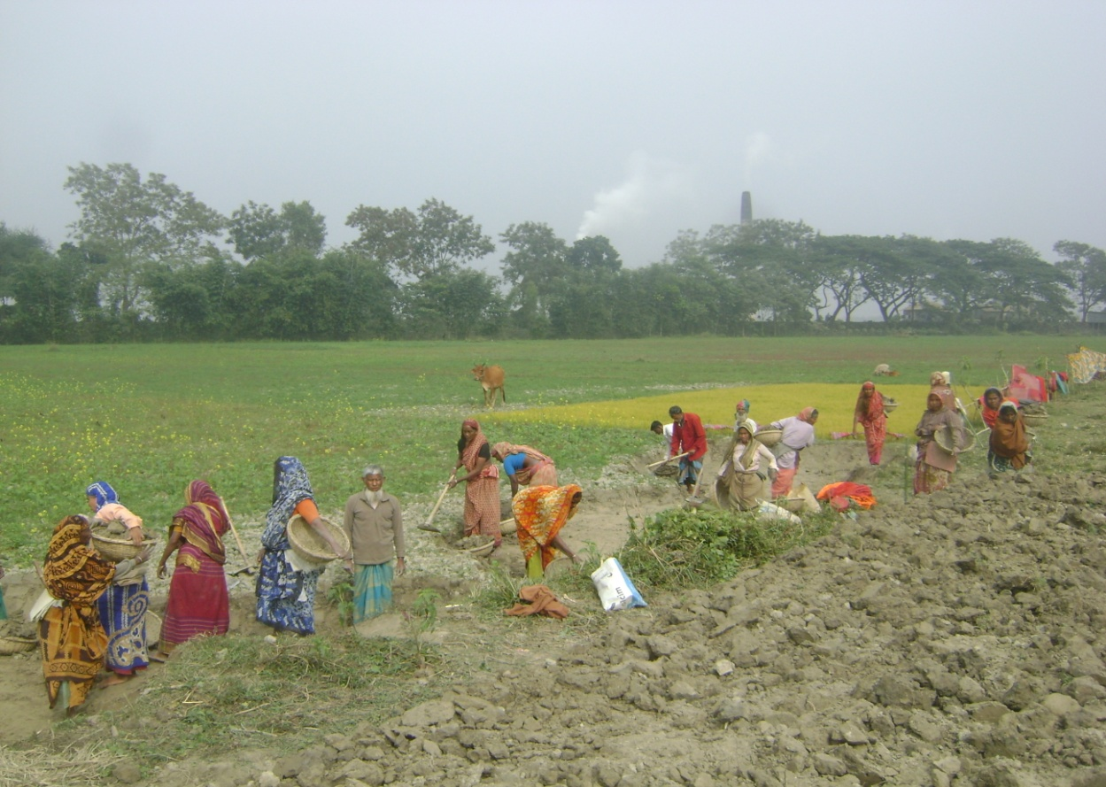

Picture of women beneficiaries of EGPP programme at Boyra union of Singair Upazilla of Manikganj district
9.0 Recommendations for Future Activities
- Ensuring the Social Safety Net for women for their economic empowerment so that they can recover from disasters;
- Expanding the coverage of the poorest women in the social safety net, and continuing the Food Security Program (VGD)
- Taking special initiatives for the safety and security of women and girls during the pre-disaster period and preparing them for disaster recovery by awareness building training;
- Rehabilitating affected disabled women, elderly people, and children who are affected by river-erosion and other natural disasters;
- Taking proper preparedness to ensure the safety of women by giving their safety as the highest priority during disaster preparedness and post disaster rehabilitation. In this regard, the security of disabled women should be considered specially;
- Food security support to lactating mother/children through ‘Nobojatra’ project should be continued to reduce malnutrition;
- Giving proper importance for raising the capacity of women to recover in a post disaster emergency situation and helping them not only by relief materials but also with psycho-social assistance;
- Taking initiatives to ensure the needs of women in the food distribution activities during post disaster emergency period fulfills the needs of women;
- Giving priorities to health issues of women during post disaster period besides feeding;
- Involving the people in disaster stricken communities to address the well-being of the destitute women during the pre and post disaster period;
- Taking institutional arrangements for education, treatment, training and rehabilitation for the disabled women;
- Address the needs of lactating mothers, and breast-feeding children, and the reproductive and hygienic needs of women at the time of relief distribution;
- The government should include women run organization in disaster risk management in broad-based community disaster coalitions.
- Ensuring involvement of women in disaster risk management at all spheres of local government and city corporations;
- Arrange national and international conference aiming at education, health, training and rehabilitation of disabled women.

