Chapter-7
Ministry of Disaster Management and Relief
1.0 Introduction
Due to global warming and climate change, the intensity of disasters all over the world is increasing gradually. Bangladesh is very often facing disaster risks from floods, cyclone, tidal surge, drought, earthquake, and other disasters due to its geographical location. These disasters leave a catastrophic impact on lives and livelihood of the affected people which directly impacts children. Disasters rob them of some of their inalienable rights; such as right to safety, right to get pure water, right to food, right to access to health care, right to education and right to survival which is contrary to the legal bindings made upon states under UN Convention on the Rights of the Child (UNCRC) and Convention on Rights of the Disabled people (CRPD). The Mission of the Ministry of Disaster Management and Relief is to strengthen overall disaster management capacity in order to reduce risks and vulnerability especially of the poor and distressed people, and to establish an efficient emergency response system adequately capable of managing large-scale disasters. The core theme of the Ministry’s Mission “reduce risks and vulnerability” alludes to children. In article 28 (4) of the Constitution of the People's Republic of Bangladesh, special importance has been given to the rights of children. In terms of casualty, in the form of death, the biggest victims are women and children in each disaster that occurs in Bangladesh because they are most vulnerable yet are given less importance. Therefore, they are given special preference when it comes to provide support, under section 27 of the Disaster Management Act, 2012.
2.0 Activities undertaken for the development of children in the light of National Policies and Strategies:
National Policy / Strategy and Description | Activities
- Protection of children is guaranteed during and after disasters under the National Child Policy, 2011 ;  - This provision has been further consolidated in Disaster Management Act, 2012;  - The National Disaster Management Policy, 2015 has been formulated under this Act. | - Inclusion of disaster management issues in primary and secondary level curriculum as stipulated in the National Disaster Management Policy, 2015;  - Inclusion of disaster management issues in all branches of higher secondary level curriculum;  - Arrangement of disaster drill, especially on fire and earthquake in all schools and colleges of the country at least once in a year ;  - Arrangement of cyclone-drill in educational institutions of coastal regions;  - Construction of multi-purpose shelter centers for the expansion of child education;  - Arrange training for teachers so that they can properly teach the children back how to act in times of disasters ;  - Operate food security support for lactating mother/children to prevent malnutrition under the 'Nabo Jatra' project;  - Expand rural electrification through installation of more solar panels under Kabikha/TR program to inspire children for education ;  - Give priority to children in all social security programs of the Ministry.
3.0 Achievement of the last three years in terms of child budget implementations:
The Ministry of Disaster Management and Relief has taken various steps for the development of children in the last 3 years that have affirmatively impacted their lives during and after disasters. Significant steps taken by the Ministry for the children during the last three years are enumerated below:
- The Ministry has been arranging food security support for lactating mother/ children to prevent malnutrition under the 'nabajatra’' project. In the last three years, Tk. 155 crore, Tk. 115 crore and Tk. 110 crore have been allocated respectively for this purpose.
- The Ministry carries out construction, maintenance and renovation of rural infrastructure through Kabikha/TR programs. Each year significant amount of money is allocated for these purposes. Kabikha/TR grants are substantially used for installing solar panels in rural areas that largely meet rural demand of electricity. Children can go on with their studies smoothly if uninterrupted supply of electricity can be ensured. In the last three years, the amount of allocations for solar panels were Tk. 1139 crore, Tk 1152 crore and Tk. 1203 crore respectively.
- The Ministry is constructing multi-purpose flood and cyclone shelters in flood and cyclone prone areas. They are serving two purposes; they are used for disaster risk reduction activities, on one hand, and are used for children’s education on the other hand. Thus, their studies remain largely unhindered. In the last three years, the total allocations for flood and cyclone shelters were Tk. 110 crore, Tk. 125 crore and Tk, 225 crore respectively.
- Disaster drills are carried out in all schools and colleges in the country to increase disaster awareness among the students. In the last 3 years, this exercise was held at least once in every school and college of the country. The expenditures for these purposes are met from the revenue budget of the Ministry. The Ministry will continue this program in future.
- Children are given priority in all social security programs organized by the Ministry which has been of great benefit for them over the years. The amount of allocations for the social security programs has increased in last 3 years. The main safety net programs are VGF, Rural Infrastructure maintenance Program (TR), GR, Cash support, Employment Generation for the Poorest (EGPP), Kabikha and Rural Infrastructure Development ( Kabita) etc. It is worth mentioning that 60% of the Ministry’s Budget is allocated on Social Safety Net Programs (SSNP) in which children are getting benefit indirectly. For the next year, more allocation for social safety net programs has been proposed.
- Rural roads have become easily accessible due to construction of Herring Bone Roads and small/medium size bridge/culverts that help children to go to schools and colleges without risks,
- In FY 2018-19 Rohingya Crisis Response project with an estimated cost of 337.89 crore was undertaken which will benefit Rohingya children.

4.0 Share of child budget in Ministry’s overall budget:
(Figures in Billion Taka)
Description | Budget 2020-21 | Budget  2019-20 | Actual  2018-19
MoDMR Budget |  | 98.72
Operating |  | 64.19
Development |  | 34.53
Child-Focused Budget in MoDMR |  | 32.85
Operating |  | 21.36
Development |  | 11.49
Total Government Budget |  | 5,232
GDP |  | 28,859
Total Government Budget as % of GDP |  | 18.13
MoDMR Budget as % of GDP |  | 0.342
MoDMR Budget as % of Total Budget |  | 1.887
Child-Focused MoDMR Budget as % of GDP |  | 0.114
Child-Focused MoDMR Budget as % of Total Government Budget |  | 0.628
Child-Focused Budget as % of Ministry Budget |  | 33.28
Source: Finance Division
The Ministry of Disaster Management and Relief has the responsibility of reducing disaster risk, coordinating rescue operation at the time of disaster, providing humanitarian aid to the affected population and implementing some of the safety-net programs of the government. These activities have critical relevance with children's Right to Protection and Right to survival. The child focused budget of this Ministry as percentage of the Ministry's total budget in the fiscal year 2019-2020 is ……. which was 28.93% and 30.6% respectively in FY 2017-2018 and FY 2018-2019.
5.0 Good practice
‘Nobo Jatra’ Project
The project was started in 2015 under the umbrella of Ministry of Disaster Management and Relief in collaboration with World Vision Bangladesh, World Food Programme, Winrock International and 3 local partner NGOs. The programme is being implemented in Dacope & Koyra Upazillas of Khulna district and Shyamnagar and Kaliganj Upazillas of Satkhira district where number of beneficiaries will stand at 8,56,116 from 2,00,495 families in 40 Unions of 5 districts within 2020.
Main Goal: Strengthen gender equitable food security, nutrition, and resilience among vulnerable people.
Main Purpose: Improve nutritional status of children of less than 5 years of age, pregnant and lactating women and adolescent girls.
Target beneficiaries: children under 2 years; b) pregnant and lactating mother; c) boys and girls; d) female led families, young girls ( 15-24 years) and e) disabled
The main activity of “Nobo Jatra” project is to provide women and child health and nutrition services (MCHN) which aims at improving nutritional status of children under 5 years of age, pregnant and lactating mother and reducing pregnancy of adolescent girls.
Main Activities of MCHN:
- Providing monthly allowance for 15 months to pregnant and lactating mothers;
- Information sharing for social and behavioral changes by using mobile phones and alternative technology;
- Observing children’s physical and mental growth giving periodic Micronutrient Powder (MNP) to children ( 6-23 months)
- Imparting basic training to public health workers on mother and child health and nutrition; and
- Using mobile technology (mHealth) for monitoring child development in real time.
Activities of MCHN in FY 2017-2018
Activity | Target | Achievement
Number of children under 2 years ( 0-23 months) who received MNP | 24034 | 19750
Number of children under 2 years ( 0-23 months) who participated in GMP session | 31963 | 35691
Number of pregnant women reached with nutrition- specific interventions | 6200 | 17425
Beneficiaries reached through NBCC awareness | _ | 208180
Number of Govt. staff received nutrition related professional training | 1920 | 1878
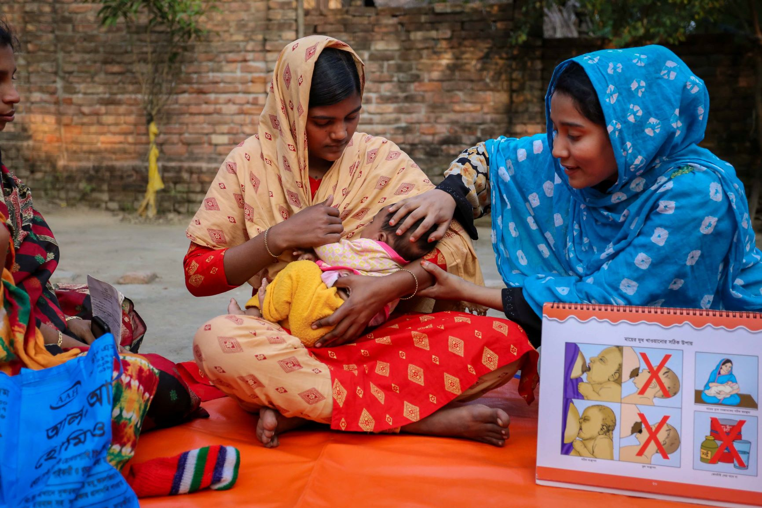

6.0 Ministry’s challenges to ensure child welfare:
One of the objectives of the Ministry of Disaster Management and Relief is to strengthen its capacity and thereby establish an efficient emergency response system capable of mitigating the risks and vulnerabilities of poor and distressed people. As mandated by the Allocation of Business, this Ministry is responsible to operate all activities that entail taking risk reduction measures, and then providing urgent help in the form of relief and rehabilitation. This implies that the clientele of this Ministry is not just particular class or group of people, its work is spread throughout the country and covers all people of all ages, caste and creed who find themselves in the risk of disaster.
The main challenges of the Ministry in ensuring children’s overall welfare:
- The Ministry needs to take up a separate project solely for the children, which it has not yet been able to do,
- A proper assessment need to be conducted to find out the specific requirements of children to propose a pragmatic child budget,
- Child nutrition issues need to be considered while providing food assistance under social safety programs.

7.0 Child centered development plan:
Type of Plan | Action taken according to Planning
Plans for 2019-20 fiscal year | - The Ministry has proposed an allocation of Tk 460 crore in FY 2019-20, for implementation of multi-purpose flood and cyclone shelters. If implemented, children’s education will remain unhindered even during disasters.  - Small/medium bridge/culvert measuring 15 meter will be constructed with an estimated cost of Tk. 500 crore and Herring Bone Bond will be constructed with an estimated cost of Tk. 400 crore for up-gradation of rural roads in FY 2019-2020 which will ease the movement of school children.  - For ensuring food for children during disasters, an allocation of Tk. 20 crore have been proposed in FY 2019-2020  - Tk. 60 crore has been proposed to allocate in FY 2019-20 for providing food security support to lactating mothers/children for combating malnutrition under 'Nabo Jatra’ project implemented by the Ministry in a bid to ensure nutrition security for children.  - Installation of solar panels has been included in the Kabikha/TR programs. Enhancement of allocation has been proposed in these programs of which 50% will be spent in solar installation and as a result coverage of electricity will increase and children's education will not be impeded.  - Tk. 99 crore has been proposed for “Emergency Multi-sector Rohingya Crisis response Project” undertaken in FY 2018-2019 with a total estimated cost of Tk. 337.89 crores in which Rohingya children will be the beneficiaries.
Mid-term plans | - Make separate arrangement for ensuring children’s overall welfare with a clear mention of required budget in future project documents of the Ministry.
Long term plans | - Include separate clauses mentioning how best children’s welfare can be protected in all Policies and Guidelines of the Ministry.
8.0 Conclusion
A country’s future progress is impossible without full blossoming of children. Almost 40% of the population of Bangladesh are children and by ensuring their social rights and welfare we can progress into the super highway of Developed Bangladesh by the year 2041. Bangladesh has made tremendous progress as reflected in Human Assets Index (HAI) which is formulated on the basis of nutrition, health, mortality, school admission, education rates and sustainable development. But this development may be truncated by a natural calamity where children invariably become a major victim. So, investments on children need to be enhanced which will reduce their vulnerabilities and risks. This Ministry has adopted several development projects that are child-centric. Besides, children are one of the main beneficiaries of Social Safety Net Programs of this Ministry. This process of putting children at the core of attention will continue in future through different projects and programs.

