Chapter-9
Local Government Division
1.0 Introduction
Children are the future leaders of the nation, the future of Bangladesh depends on the children. One of the main targets of Milennium Development Goals and Sustainable Development Goals is to ensure pure driking water and sanitation facilities for all. Research suggests that water-borne diseases pose one of the gravest health risks for the country. Ensuring safe drinking water, sanitation and healthy environment are important ingredients for the lives of children which form one of the major tasks of different local government institutions, such as zila Parishad, upazila Parishad, Union Parishad, Pouroshova, City Corporation, LGED, DPHE, Dhaka wasa, Chittagong wasa, Rajshahi WASA, Khulna WASA etc. In this context, LGD has immense significance in child-sensitive budget discourse.
2.0 Activities undertaken for the development of children in the light of National Policies and Strategies:
National Policy/Strategy and Description | Activities
National Nutrition Policy 2015:  The main target of this policy is to ensure nutrition security at each level of life cycle, ensure appropriate and sufficient nutrition for pregnant mothers and guarantee safe food for adolescents. | - Ensure up to four pre-natal care visits during pregnancy and give the mother TK. 200/- in each visit;  - Provide Tk. 500/- to the beneficiary per visit for height and weight check every month for children aged 0-24 months:  - Provide Tk. 1000/- to the beneficiary for height and weight check in every 3 months for children aged 25-60 month.  - Provide Tk. 500/- per visit for attending child nutrition and cognitive development education sessions every month for Pregnant women and mothers of children aged 0-60 month:  - Strengthen Union Parishad for implementing Social Safety net Program through establishment of Safety Net Cell (SNC).  - Provide ANC and GMP related health service to mother and children and capacity building of community clinics to create awareness about nutrition.
Local Government (City Corporation) Act, 2009 and Local Government (Pourashava) Act, 2009 have delegated the responsibility of heath security of local citizens to local government institutions. | - Provide pre-natal services;  - Provide delivery services (normal and caesarean sections)  - Provide infant and child health care;  - Provide treatment of general diseases such as; fever, cough, minor injuries etc. along with other contagious diseases;  - Provide treatment for Acute Respiratory Infections (ARI) and diarrhea;  - Measure weight and height of children between 0-24 months.
National Pure Drinking Water Supply and Sanitation Policy 1998: This policy aims at supplying pure drinking water at affordable prices to all. A target has been fixed to establish one single water point for every 50 persons. | - Take initiative for supplying pure drinking water at an affordable price;  - Ensure pure drinking water for 100% population at urban areas and for 90% population at rural areas;  - Complete sanitation program up to 99%.  - Establish a single water point for every 50 persons.
National Arsenic Mitigation Policy 2004:  The main aim of this policy is to provide alternative source of water in arsenic affected areas. | - In order to provide alternative source of water in arsenic affected areas, a country wide project titled ‘Mitigation of Arsenic risks in water supply’ has been undertaken.
Planning for development of Water Supply and Sanitation Sector 2011-2015:  This sector plan aims at combining all government activities regarding water supply and sanitation and strengthening planning, implementation and monitoring strategies. | - Thirty development projects are being implemented on water supply and sanitation.
Birth and Death Registration Act 2004:  According section 8 of this Act, birth registration of child has been made mandatory within 45 days of birth. | - Advertisement and awareness activities for ensuring birth registration within 45 days of birth;  - Launching online birth registration.
3.0 Achievement of the last three years in terms of child budget implementations:
- The Project ISPP (JAWTNO) has 03 (three) components to help smooth implementation of the project activities: MIS, Training, Beneficiary Outreach and Enrolment (TOE), Operational Review Services and one for CNCD-NGO;
- Enrolment: It has already enrolled 1,23,950 beneficiaries under 75 union following Bio- metric systems;
- It has transferred BDT 1351.02 lakh to Bangladesh Post Office for distributing among the 20,921 beneficiaries by using electronic cash cards;
- Have established Safety Net Cell (SNC) at 308 unions. Deployed 308 Safety Net Program Assistants (SPA) for management of SNC;
- It has installed a central MIS database for recording beneficiary information, preparing payment list and transfer of money to the beneficiaries;
- Education (Class 1-7) grants distributed to 10,607 recipients to prevent drop out;
- Education (Class 1-7) grants distributed to 2,767 recipients to prevent early marriage;
- 39,97,219 Child health services has been provided under the project titled Urban Primary Health Care Services Delivery (Phase-II) such as-
- EPI was 8,28,542 (Coverage in PA areas- 91.3%)
- NID was 17,67,528 (Coverage in PA areas- 93%)
- Control of Diarrhea 2,59,960 (Coverage in PA areas- 37%)
- Control of Acute Repertory Infections (ARI) was 3,43,258 (Coverage in PA areas- 49%)
- Measles was 2,315
- Child Nutrition was 1,42,667 (Coverage in PA areas- 21%)
- Vit-A was 99,163(Coverage in PA areas- 85%)
- Iodine deficiency was 782
- Neonatal Care was 5,53,018 (Coverage in PA areas- 51%)
- Besides, water, sanitation and health awareness have been ensured for children in 39,300 primary and 1,500 secondary schools through various projects
4.0 Share of child budget in Ministry’s overall budget:
(Figures in Billion Taka)
Description | Budget  2020-21 | Budget  2019-20 | Actual  2018-19
LG Division Budget |  | 342.42
Operating |  | 43.22
Development |  | 299.2
Child-Focused Budget in LG Division |  | 37.73
Operating |  | 4.76
Development |  | 32.97
Total Government Budget |  | 5,232
GDP |  | 28,859
Total Government Budget as % of GDP |  | 18.13
LG Division Budget as % of GDP |  | 1.19
LG Division Budget as % of Total Budget |  | 6.54
Child-Focused LG Division Budget as % of GDP |  | 0.13
Child-Focused LG Division Budget as % of Total Government Budget |  | 0.72
Child-Focused Budget as % of Ministry Budget |  | 11.02
Source: Finance Division
Safe drinking water, sanitation and hygiene are important components of children's Right to Survival which falls under the jurisdiction of the Local Government Division. In addition, the birth registration, which is an important component of children's Right to Participation is also managed by the local government bodies. The child sensitive budget of this Division as percentage of the Division's total budget has increased to 8.84 percent in FY 2018-19 from 6.66 percent in FY 2017-18.
5. Good Practice
“Dreaming to fulfill my dream!”
Monika Begum, 26, a young woman with a lot of promise lives in the South Ghagua Union of the Sadar upazila of Gaibandha district. She was enrolled as an ISPP beneficiary two years back. The family of Monica includes her husband and two minor children. They live by the side of a river in the government khas land. The boy reads in class I while the baby-girl is only 25 months old.
Khalil Mia, her husband said, “As the only earning person, I pulled rickshaw earlier but it wasn’t enough to meet the expenses of my family, so I started to work as a brick mason.” “Surely’, he added, “it was not possible on my part to provide nutritious food to my two kids that caused frequent sickness. At this pont we came across the ISPP-JAWTNO Project. The authority conducted a number of sessions introduce us to various nutritious foods. They also taught us how to feed kids nutritious food for achieving better health. We are now following the instructions learnt from these sessions, and accordingly, trying to feed the kids. As a result, our kids are growing better. We are also taking weight and height of our kids periodically and attending Clinics and CNCDs.” Khalil further emphasized, “I always encourage Monica, my wife, to attend the sessions regularly, because the sessions teach her a lot about child nutrition and nutritious foods, childcare, hygiene and wellbeing of life.”
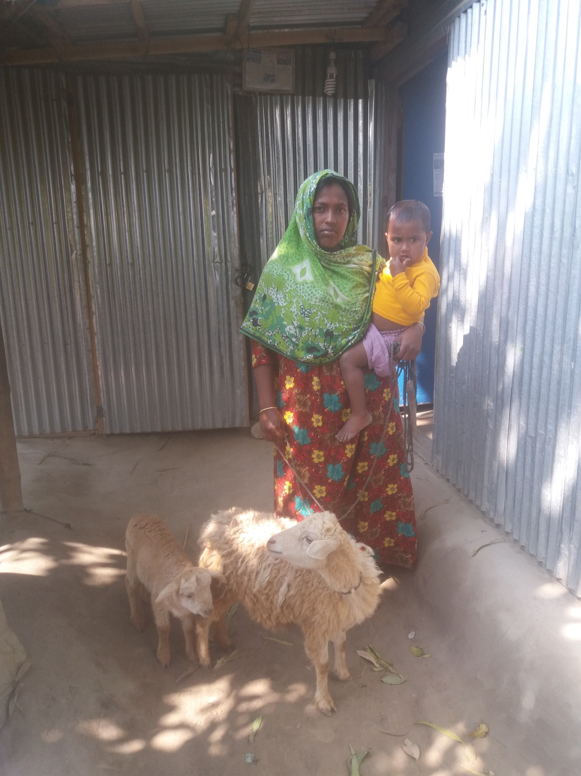
Since her enrollment, Monica got thirteen thousand taka till now. At first, she bought two sheep which gave birth of four. By selling the sheep she bought a cow recently. Monica studied only up to class V. As a mother, she is now quite confident about her and her family members as well.
“I don’t want my children go on like me. Therefore, I am determined about their proper education for better future.” said Monica. She is now attending all the CNCD sessions along with her children and learning about child health and nutrition. She is also learning about the importance of taking nutritious food and its use for her kids. She is thankful to ISPP-JAWTNO Project as well as to the government for introducing such a beneficial project for the betterment of the poor people.
6.0 Ministry’s Challenges to ensure child welfare:
- Scarcity of household data with poverty score, required for identifying real beneficiaries;
- Delay in starting child Welfare related development projects;
- Projects undertaken by ministries are not exclusively based on child benefit; neither any project is undertaken solely considering children;
- Dearth of proper assessment of children’s exact requirement;
- Improper site selection for child centric sanitation and water sourcing;
- People migrated from village to urban areas;
- Low income people in urban areas are forced to change their settlements;
- Drop out from Schools;
- Environment in the urban informal settlement is an obstacle for physical and mental development of Children;
- Lack of medical services for child suffering from malnutrition;
- The ongoing activities are being interrupted due to procrastination of NGO selection and contract negotiation;
7.0 Child Centric Development Plans
Planning Period | Activities
Plans for FY 2019-20 | - Every Child aged 0-24 months will be provided with Tk. 700/- per visit for each month’s height and weight check;  - Every child aged 2-5 years will be provided with Tk. 1500/- per visit for every three month’s height and weight check;  - Every Pregnant woman and mother of child aged 0-5 years will be provided with Tk. 700 per visit for attending child nutrition and cognitive development (CNCD) education sessions every month;  - Provide services to address/combat pregnancy related complications;  - Enhancement of efficiency of Union Parishads for implementing social safety net programs through establishment of Social Safety Net cell (SNC);  - Enhancement of Efficiency of community clinics in providing health care to mother and children (ANC and GMP) and in building awareness about proper nutrition;  - Capacity building of the Bangladesh Post Office for cash benefit payment to the beneficiaries through cash card under electronic system;  - 100,000 Education grants (class 1-7) will be distributed to prevent dropout of child living in urban poor settlement;  - 3,000 Education grants (class 8-10) will be distributed to prevent early marriage of school going girls living in urban poor settlement;  - Awareness campaign will be conducted to prevent early and forced marriage;  - Nutrition awareness campaign will be conducted, and 9,000 nutrition grants will be distributed to the pregnant women and lactating mothers to improve level of nutrition of children;  - Training on nutrition will be conducted for leaders of Community organizations, City Corporation and Municipality health staff;  - Playgrounds and parks will be constructed;  - Initiative will be taken to Identify and treat children with severe malnutrition.  - Nutrition services will be started in urban areas,;  - Initiatives will be taken to ensure the nutrition services for the disabled and street children.
8.0 Conclusion
The future development and prosperity of any nation depends largely on the present state safety and wellbeing of children. Increased direct investment on them is a sine qua non for making an efficient human capital in the days to come. Proper education and health care must go hand in hand in a healthy environment. With these end in view, the local government division is running a number of projects that will pave the way for children’s overall development. However local government institutions need to be more active in building playgrounds and parks for ensuring a healthy growth of children.

