Chapter-14
Ministry of Cultural Affairs
1.0 Introduction:
Culture is the mirror that reflects the overall behavior, way of living and approach towards life of particular group of people, society and by extension, nation. It is just about how people live their day to day lives and how the streams of lives move on. The main elements of culture are: knowledge, belief, ideology, education, language, ethics, laws, customs and so on, by which people identify themselves as members of a particular society and nation.
Bangladesh has always tried, by all means, to uphold its cultural image and heritage. Article 23 of the second part of the Constitution of the People's Republic of Bangladesh states: "The state shall adopt measures to conserve the cultural traditions and heritage of the people, and so to foster and improve the national language, literature and the arts, so that all sections of the people are afforded the opportunity to contribute towards and to participate in the enrichment of the national culture”.
Culture plays a pivotal role in the formation of an ideal society. The contribution and importance of the Ministry of Cultural Affairs in shaping the life of the children who hold the keys of the country’s future is significant. It is working relentlessly to improve and preserve the culture, tradition, language, arts and crafts, archeological relics, activities of the all ethnic groups. In addition, it has taken plethora of positive initiatives to ensure an enlightened future for children by involving them in cultural activities.
2.0 Activities undertaken for the development of children in the light of National Policies/Strategies
Policy/Strategy and its brief description | Activities
National Cultural Policy, 2006:  Ministry of Cultural Affairs will take effective steps for preservation, promotion and development of cultural heritage, history, arts, language and literature, archeological relics, folk arts and crafts, fine arts, books and libraries and other cultural elements. Ministry will take necessary steps for encouraging artists and litterateurs and take initiatives for protecting rights of creative works through coordination among attached departments. The Ministry will take essential measures to preserve and expand diversified cultural elements, language and the culture of various indigenous groups. | - Cultural practice in the form of music has been started at secondary school level to ignite patriotism among children and to make them culturally enriched citizens. This program will gradually be expanded throughout the country;  - Impart training on drama, music, dance, painting and acrobatics etc. for children;  - Arrange free visits for children in different museums and archaeological sites on special days;  - Organize music, art, recitation and speech competition on various national days to unfold the creative talent of children;  - Deliver special services by setting up special corners for publishers of children’s books in the Ekushey Book Fair;  - Organize essay writing and reading competition for children on different special days with a view to develop knowledge and sharpen intellectual faculty of children, by Directorate of Public Libraries;  - Create children corner in public libraries for young readers;  - Administer cultural activities for children of different ethnic groups living in different areas of the country through their own institutions.
3.0 Achievement of the last three years in terms of child budget implementations:
The Ministry of Cultural Affairs has been working hard for the exhibition and conservation of all indigenous cultural heritage and crafts, fine arts and archaeological relics throughout the country. During the last three years, the Ministry has achieved the following goals by implementing child-specific activities through its 17departments/autonomous institutions:
- In the last three years, Tk. 1.50 crore were allocated for organizing cultural programs on Rabindra birth anniversary in 35 upazilas of 4 districts; namely: Kushtia, Sirajganj, Khulna, and Naogaon. In these programs painting, poetry recitation, speech, book reading and essay writing competition were organized for children. In the last three financial years, about 945 children were awarded. On the birth anniversary of Nazrul, Tk. 1.50 crore was allocated in 61 upazilas of six districts; namely: Dhaka, Chittagong, Comilla, Mymensingh, Chuadanga and Manikganj. On this occasion, arrangements for painting, poetry recitation, lecture, book reading and essay writing competition were organized. In the last three years, 75 thousand children attended this event. In addition, 4,941 children were given prizes. In 2016-17 and 2017-18 financial years, Tk.1.68 crore was allocated to observe ‘Bengali New Year’. In the last three financial years, about 1.50 crore children participated in different programs in 64 districts and 482 upazilas on this occasion.
- In 2016-17 fiscal year, ‘cultural practice’ program was adopted for the first time. In that year, in 180 schools of 18 districts and in 2017-18 fiscal year in 300 schools of 30 districts, this program was arranged to create patriotism among the secondary school students and to develop them culturally enriched in humane values. In the current fiscal year, steps were taken to expand cultural activities in 836 schools of 64 districts. Under this program, one harmonium and one set of drums for each school totaling 480 harmoniums and 480 sets of drums were supplied. Under this program, one musical instructor and one musician were appointed for six months in each school. In the current fiscal year, steps have been taken to expand this program in 836 schools.
- In 2007-18 fiscal year, in order to familiarize and involve them with the mainstream heritage and culture of Bangladesh, and to preserve, practice, exercise own language and culture of the ethnic groups, 1200 children were trained on various activities such as music, dance, recitation, drama, standard pronunciation, etc. under the ministry’s supervision. In the 2015-16 and 2016-17 fiscal years, the number were 800 and 844 respectively. In 2016-17 and 2017-18 financial year, the number of children attended was 25,775 and 10,676 respectively.
- In order to get the children acquainted with the national heritage, 20,387 children were given the opportunity to visit the museum and archeological sites without ticket. In the years 2016-17 and 2017-18, number of children availed the opportunity to visit was 25,775 and 10,676 respectively.

4.0 Share of child budget in Ministry’s overall budget
(Figures in Billion Taka)
Description | Budget  2020-21 | Budget  2019-20 | Actual  2018-19
Ministry of Cultural Affairs Budget |  | 5.76
Operating |  | 3.16
Development |  | 2.6
Child-Focused Budget in Ministry of Cultural Affairs |  | 2.01
Operating |  | 1.1
Development |  | 0.91
Total Government Budget |  | 5,232
GDP |  | 28,859
Total Government Budget as % of GDP |  | 18.13
MOCA Budget as % of GDP |  | 0.02
MOCA Budget as % of Total Budget |  | 0.11
Child-Focused MOCA Budget as % of GDP |  | 0.01
Child-Focused MOCA Budget as % of Total Government Budget |  | 0.04
Child-Focused Budget as % of Ministry Budget |  | 34.90
Source: Finance Division
The right to have leisure, participate in recreation and cultural activities, being mainly under the purview of the Ministry of Cultural Affairs, it was included in the child budget report in 2018-19 financial year. The budget of this ministry was 0.02 percent of the GDP and 19.99 percent of the total budget of the Ministry was spent in child sensitive activities in the fiscal year 2018-19.
5.0 Case Study
In order to develop culturally rich future generations, the Ministry of Cultural Affairs has taken initiative in the 2016-17 fiscal year for conducting 'cultural practice' activities in secondary schools. It is to be noted that, in the previous two financial years, this program had been taken to 480 schools. Under this program, 'culture practice' is being conducted in 836 schools in 64 districts in the current fiscal year.
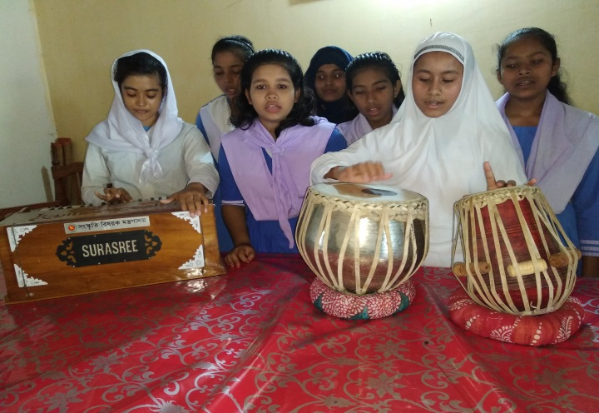
Ghumdum High School in Naikhangchhari Upazila of Bandarban district is such a school.There was no institutional arrangement of musical education in this school. But many students were good at music and were interested in learning music formally. Their participation was spontaneous in school events too. Upazila Nirbahi Officer was present at a ceremony. He always appreciated the cultural activities of this institution. He learnt that there was no music teacher in the school and the students were not getting chance to learn music formally. Immediately, he informed the matter to the Ministry of Cultural Affairs through Deputy Commissioner. A harmonium and a set of drums were supplied under the 'culture practice' program from the ministry. Honorarium for two music teachers were also arranged (monthly Tk.1500 and Tk.2100). They take classes regularly one day per week. As a result, students are getting an opportunity to practice culture alongside school education.
6.0 Ministry’s Challenges to ensure child welfare
The Ministry of Cultural Affairs is working to develop a progressive and non-communal society free from religious bigotry which was in fact the glorious heritage of our country. In order to inspire the people in the spirit of culture and liberalism, the ministry is taking specific target oriented activities. Apart from trying to develop the culture of the larger population, the ministry has taken a lot of activities to revive and develop the indigenous culture of small ethnic groups. There are many challenges for child-focused budget preparation. Some of them are:
- Lack of specific guidance or methods for formulating, implementing, monitoring and evaluating child-centric budget;
- Insufficiency of allocation for children and insufficiency of allocation for children in ministry’s sanctioned budget;
- Lack of training in order to involve children with cultural activities ;
- Lack of opportunities for children in participating different cultural activities;
- Lack of trained manpower to take care of autistic children participants in cultural activities separately,
- Limited activities of field level offices.
7.0 Child centered development plans
Type of Plan | Action taken according to Planning
Plan for FY 2019-20 | - To arrange training programs for children on various branches of arts and crafts;  - To extend cultural activities for the students of 850 secondary schools;  - To arrange cultural competition and drama festivals for children, adolescent and youth at the national level;  - To arrange acrobatic exhibition of children in different areas of the country;  - To Provide training and arrange exhibition for specially abled disabled children and neglected children;  - To arrange free access for children to museums and archaeological sites on special days;  - To organize rallies, reading and writing competitions and seminars for children;  - To organize cultural programs for the disabled and specially challenged children and to create a learning friendly environment for them in libraries;
Medium Term Plan | - To establish a corner to be used as a library in every union parishad complex of the country;  - To adopt different development programs for the welfare of children through Shilpakala Academy; and  - To bring the students of all secondary schools of the country under ‘cultural practice’ program.
Long Term Plan | - To adopt a country-wide cultural competition in order to attract children and adolescents in arts and literature;  - To establish a public library in each upazila in order to disseminate knowledge and attract students in reading;  - To adopt a project for establishing Shilpakala Academy in each upazila for the development of children’s literature and cultural faculty development; and  - To adopt programs/projects in school/college level for literary practice of the student.
8.0 Conclusion
The government is committed to the welfare of the children. The Ministry of Cultural Affairs always strives to present a prosperous state through healthy/beneficial cultural activities for the children throughout the country. In order to create moral, humane, scientific and social values ​​among children in the light of National Cultural Policy, the Ministry of Cultural Affairs will take appropriate steps including arranging film festivals for children, providing various types of training, formulating curriculum for the education of cultural heritage and culture and making films for the children.

